**Residential Automation System**

**Design Document**

**Version 1.0**



**Group Id:** F210220D71

**Supervisor Name:** Ijaz Ullah

**Revision History**

|  |  |  |  |
| --- | --- | --- | --- |
| **Date (dd/mm/yyyy)** | **Version** | **Description** | **Tested By** |
| **9/9/2023** | **1.0** |  | Bc200405760  Muqadass  Bc200405764 Amina |
|  |  |  |  |
|  |  |  |  |
|  |  |  |  |

**Table of Contents**

1. Introduction of Design Document
2. Entity Relationship Diagram (ERD)
3. Sequence Diagrams
4. Architecture Design Diagram
5. Class Diagram
6. Database Design
7. Interface Design
8. Test Cases

1. Introduction of Design Document

The Design Document maps the requirements into architecture-independent of how these requirements will be accomplished. The architecture defines the components, their interfaces, and behaviors. In the Design Phase, we transform the requirements gathered during the Analysis Phase into a Design Document that accurately describes the design of the system.

The purpose of the Design Phase is to transform the requirements into complete and detailed system design specifications once the design is approved the Design Document will serve as input to the Development Phase. Tools and techniques used in this phase are listed below:

* ER Diagram
* Sequence Diagram
* Architecture Design Diagram
* Class Diagram
* Database Design
* Interface Design
* Test Cases

1. 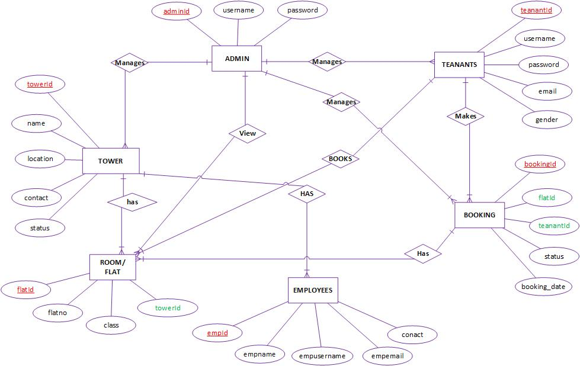Entity Relationship Diagram (ERD)
2. Sequence Diagrams

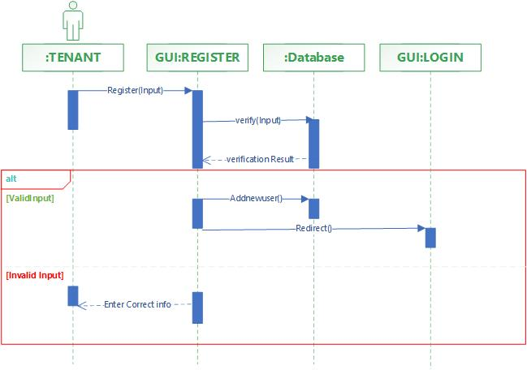Registration:

Login Panel:

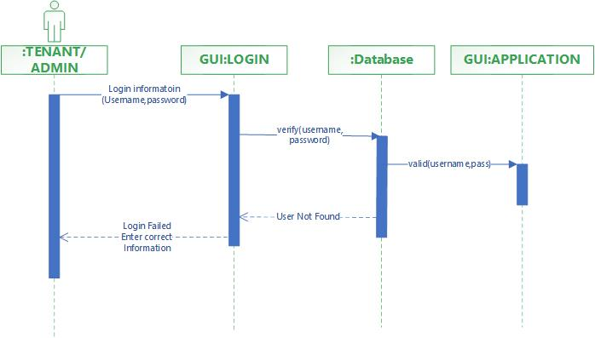

Add Employee:

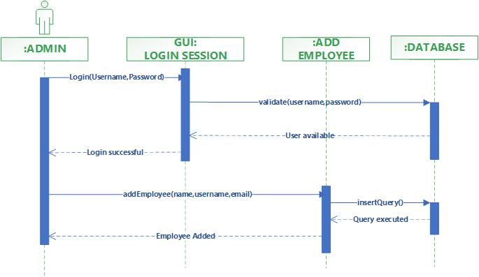

Add Flat:-

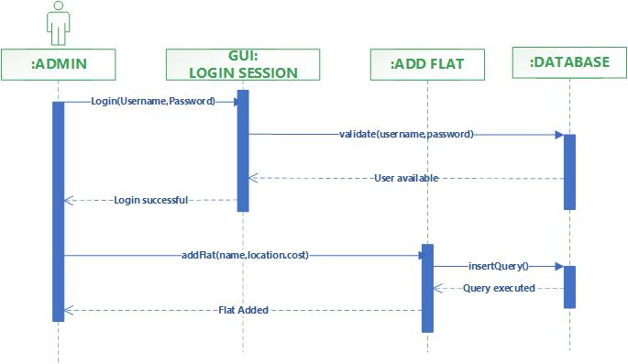

Add Room:

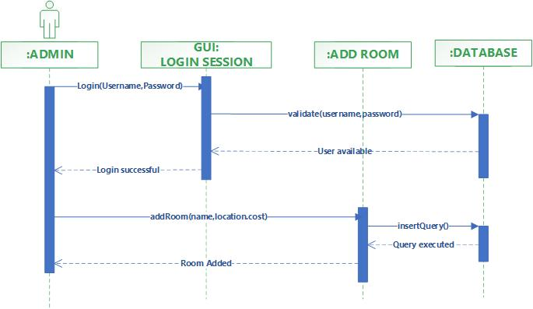

Add Teanant:-

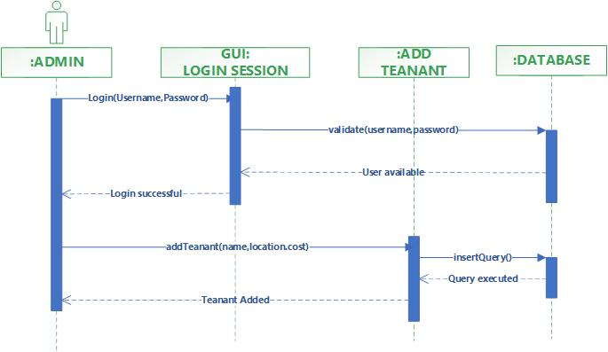

Make Booking

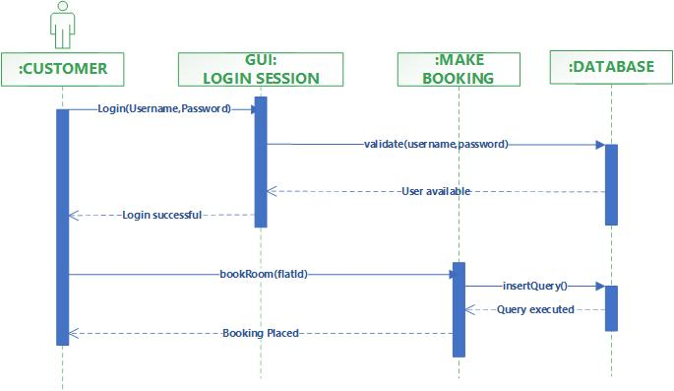

Manage Booking:-

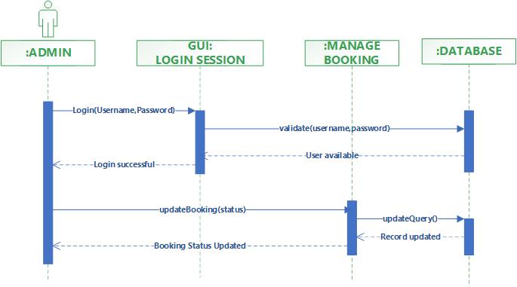

Search Room:

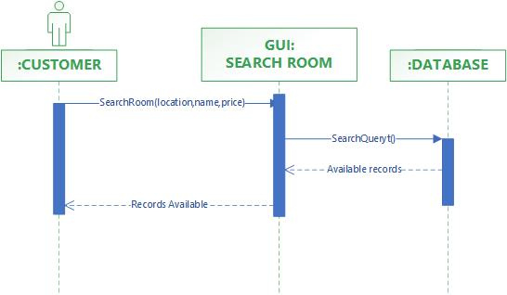

View Booking:-

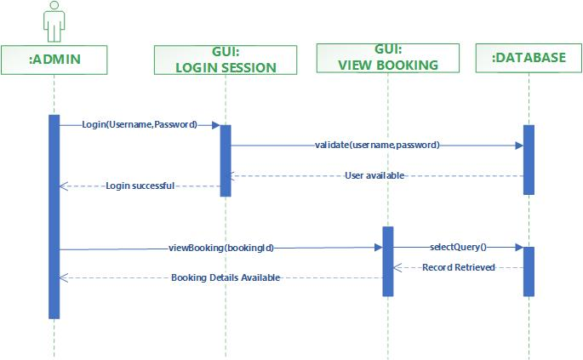

LOGOUT:-

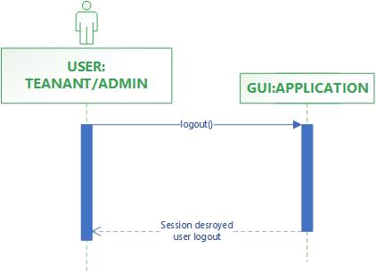

1. 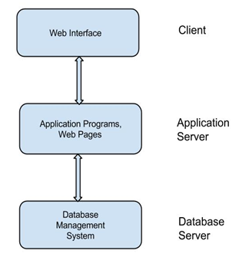Architecture Design Diagram
2. Class Diagram

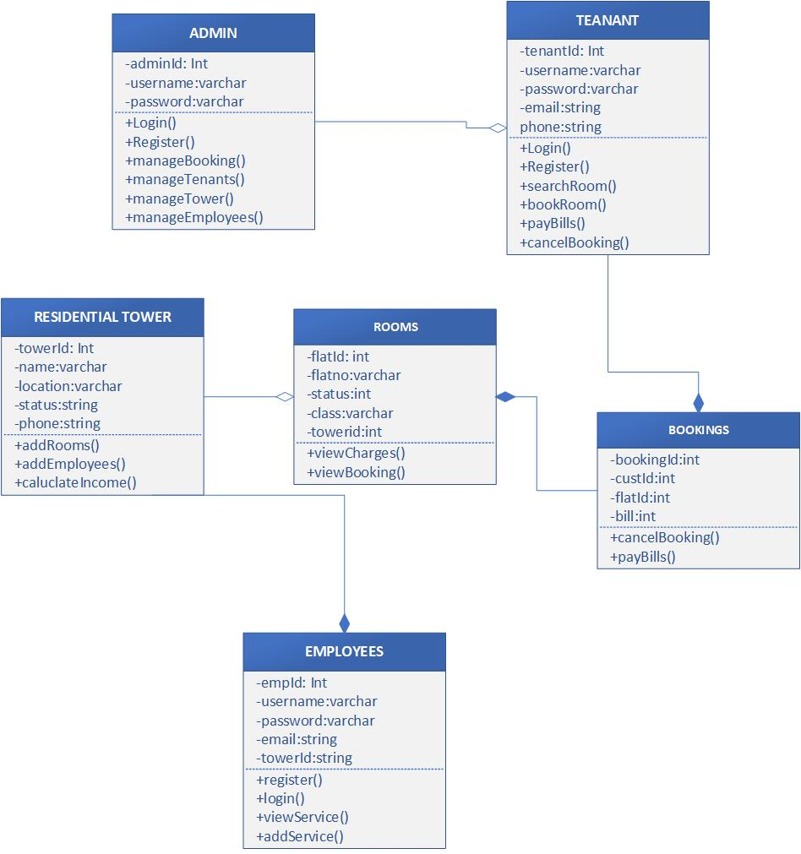

1. Database Design

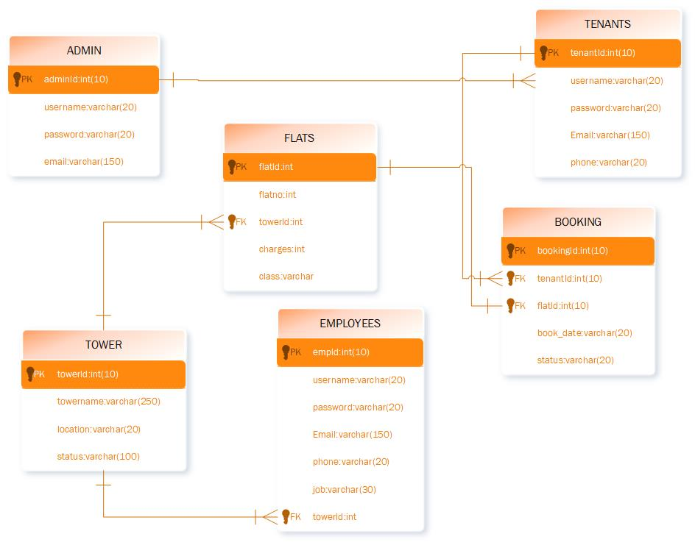

1. Interface Design
2. Test Cases

**REGISTER:**

|  |  |
| --- | --- |
| Pre-condition | Application interface must be available. |
| Action | 1. Open application interface of create account 2. Fill the form of registration 3. Click on “Register” button to get registered |
| Expected Results | Customers/Teanants successfully created in database. |
| Results | Pass |
| Tested By | Bc200405760 (Muqaddas) Bc200405764 (Amina) |

**LOGIN:**

|  |  |
| --- | --- |
| Pre-condition | Actors must be registered with our website , Application interface must be available |
| Action | 1. Open application interface of login 2. Enter user name and password 3. Click on “Login” button |
| Expected Results | Actors successfully login and able to further work |
| Results | Pass |
| Tested By | Bc200405760 (Muqaddas) Bc200405764 (Amina) |

**ADD FLAT:**

|  |  |
| --- | --- |
| Pre-condition | Onwer user of the system must be registered with our website and logged in. |
| Action | 1. Login as Owner 2. Fill add flat form 3. Click on “Add Flat” button |
| Expected Results | Flat successfully added and available to tenants for booking |
| Results | Pass |
| Tested By | Bc200405760 (Muqaddas) Bc200405764 (Amina) |

**ADD ROOM:**

|  |  |
| --- | --- |
| Pre-condition | Onwer user of the system must be registered with our website and logged in. |
| Action | 1. Login as Owner 2. Fill add room form 3. Click on “Add Room” button |
| Expected Results | Room successfully added and available to tenants for booking |
| Results | Pass |
| Tested By | Bc200405760 (Muqaddas) Bc200405764 (Amina) |

**ADD TEANANT:**

|  |  |
| --- | --- |
| Pre-condition | Application interface must be available. And system must be logged in as Owner |
| Action | 1. Open application interface of create account 2. Fill the form of add teanunt 3. Click on “Add Teanuant” button to get registered |
| Expected Results | Customers/Teanants successfully created in database. |
| Results | Pass |
| Tested By | Bc200405760 (Muqaddas) Bc200405764 (Amina) |

**ASSIGN FLAT:**

|  |  |
| --- | --- |
| Pre-condition | Application interface must be available. And system must be logged in as Owner |
| Action | 1. Open application interface of create account 2. View all booking requests 3. Assign room no or flat no to the requested customer |
| Expected Results | Customers/Teanants successfully created in database. |
| Results | Pass |
| Tested By | Bc200405760 (Muqaddas) Bc200405764 (Amina) |

**ADD EMPLOYEE:**

|  |  |
| --- | --- |
| Pre-condition | Application interface must be available. And system must be logged in as Owner |
| Action | 1. Open application interface of create account 2. Fill the form of add employee 3. Click on “Add Employee” button to add employee |
| Expected Results | Employee successfully created in database. |
| Results | Pass |
| Tested By | Bc200405760 (Muqaddas) Bc200405764 (Amina) |

**COLLECT RENT:**

|  |  |
| --- | --- |
| Pre-condition | Application interface must be available. And system must be logged in as Owner |
| Action | 1. Open application interface of create account 2. Check rent of all the teanants living in the block 3. Collect rent from those whose rent is due |
| Expected Results | Rent collected and deposited in finance department |
| Results | Pass |
| Tested By | Bc200405760 (Muqaddas) Bc200405764 (Amina) |

**SEARCH ROOM:**

|  |  |
| --- | --- |
| Pre-condition | Application interface must be available |
| Action | 1. Open application interface and fill the criteria of search room/flat. 2. Click on the “SEARCH” button |
| Expected Results | All rooms/flats that fall on the search criteria will be displayed on the website |
| Results | Pass |
| Tested By | Bc200405760 (Muqaddas) Bc200405764 (Amina) |

**BOOK ROOM:**

|  |  |
| --- | --- |
| Pre-condition | Application interface must be available |
| Action | 1. Open application interface and fill the criteria of search room/flat. 2. Select Room you want and click on book room |
| Expected Results | Room booking request will be sent to owner of system |
| Results | Pass |
|  |  |
| Tested By | Bc200405760 (Muqaddas) Bc200405764 (Amina) |

**LOGOUT**

|  |  |
| --- | --- |
| Use Case id | **10** |
| Use Case title | **LOGOUT** |
| Description | This use case allows all the actors of the system to logout from website. |
| Pre-condition | The application interface must be available and any of the actor must be Logged in. |
| Action | 1. Open application interface. 2. Click on Logout Button. |
| Expected Results | Session is destroyed and actor will be logout from system. |
| Alternative Path: | Force close website. |
| Exception: | If session is empty than this feature is not available. |
| Results | Owner, Customer/teanunt |
| Tested By | Bc200405760 (Muqaddas) Bc200405764 (Amina) |